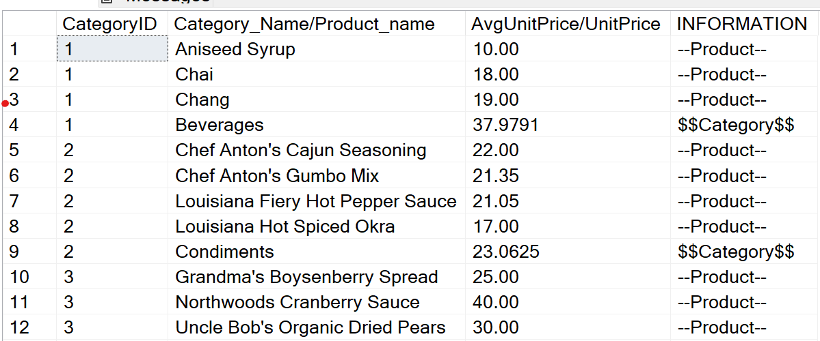

# Data-Analyst-Portfolio

Here you can see an overview of my skills as a Data Analyst, its divided into multiple parts, each showcasing diferrent areas of expertise a Data Analyst must have:
1) SQL demonstrations
2) Tableau Visualizations
3) PowerBI Visualizations
3) Data Analysis with Python

